Sentinel East™

Advanced Underground Hydro Power Battery System  
Visual & Technical Brief  
By Clive Appleby | Founder & CEO, Eclipse Inc.  
July 2025 | www.cliveappleby.com/news/sentinel-east  
  
[Note: This document includes crop marks and bleed space for professional printing.]

[BLEED AREA: Ensure all images extend 3mm beyond the document edges.]  
[CROP MARKS: Apply at final trimming size.]

# Executive Summary

The Sentinel East Hydro Power System is not just an infrastructure project—it’s a visionary leap in energy storage and sustainability.  
  
Sentinel East combines cutting-edge subterranean hydroelectric storage with ecological sensitivity, balancing grid stability with environmental stewardship. This is pumped storage reimagined—a colossal, cinematic-scale battery beneath the earth, delivering power when the world needs it most.

# The Storyboard: A Cinematic Energy Journey

## Scene 1: The Surface Intake at Sunrise

A sleek, minimalist intake structure sits quietly at the shore of an autumn lake. Nature and technology merge, signaling a new era of aesthetic infrastructure.

[Ensure image includes 3mm bleed and is positioned with crop marks.]

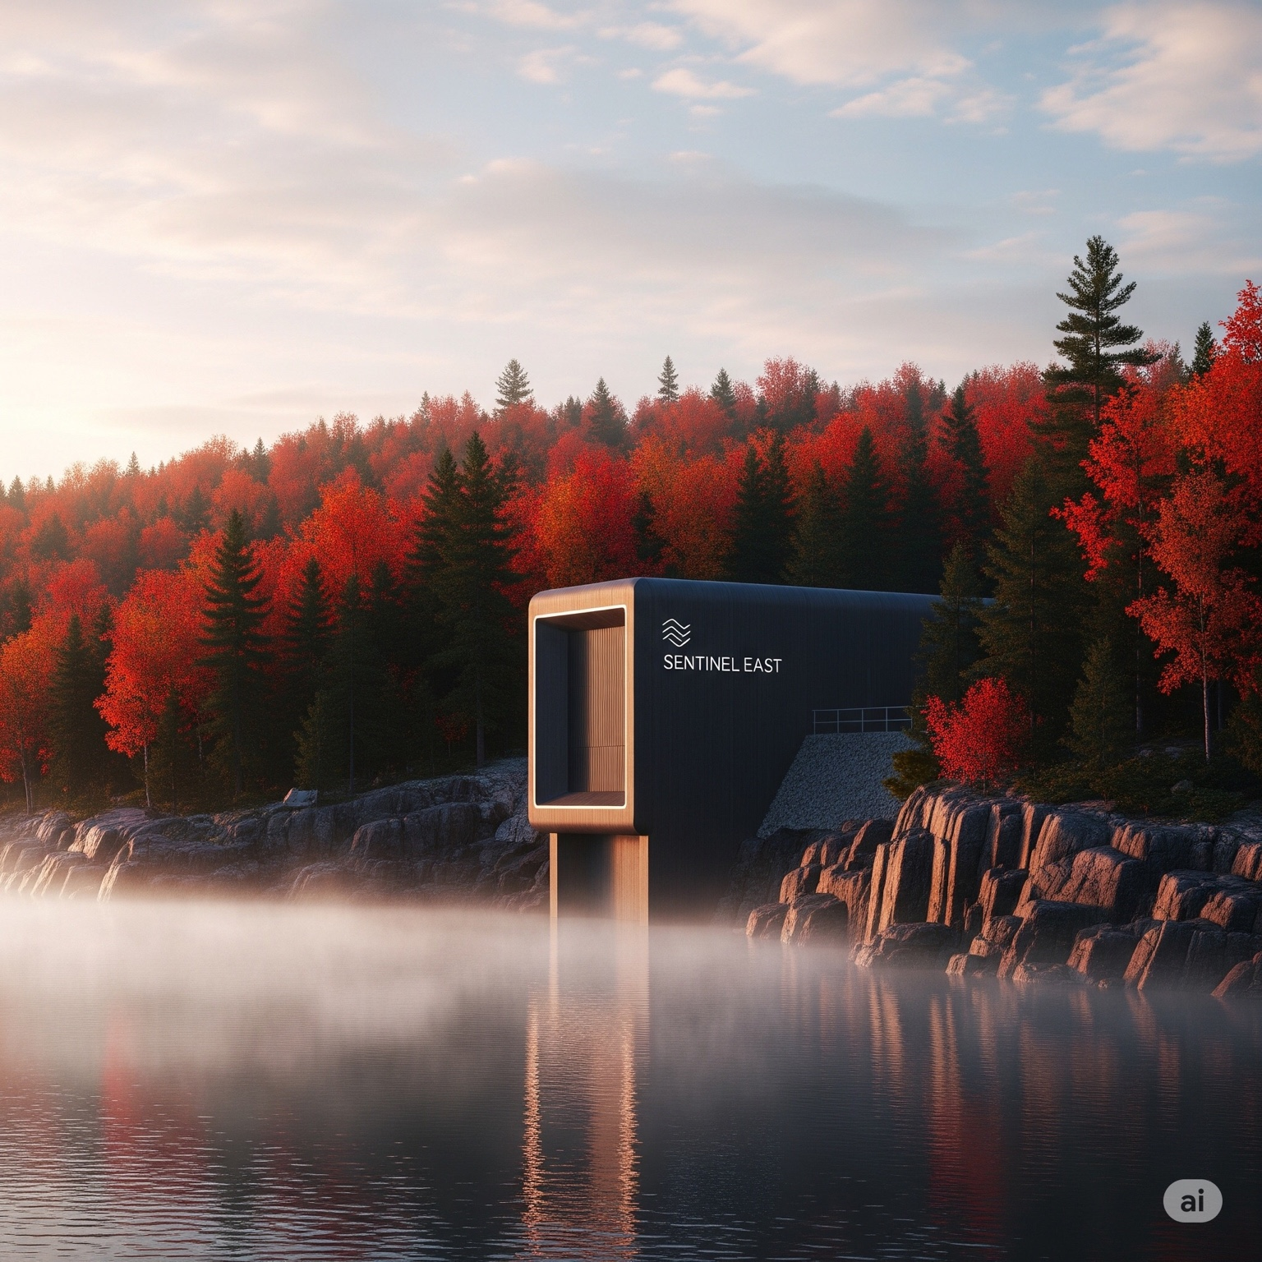

## Scene 2: The Subterranean Turbine Cavern

Deep below the surface, a vast underground cavern hums with kinetic energy. Arrays of multi-tier vertical turbines convert cascading water into electricity, powered by a 1200-meter drop.

[Ensure image includes 3mm bleed and is positioned with crop marks.]

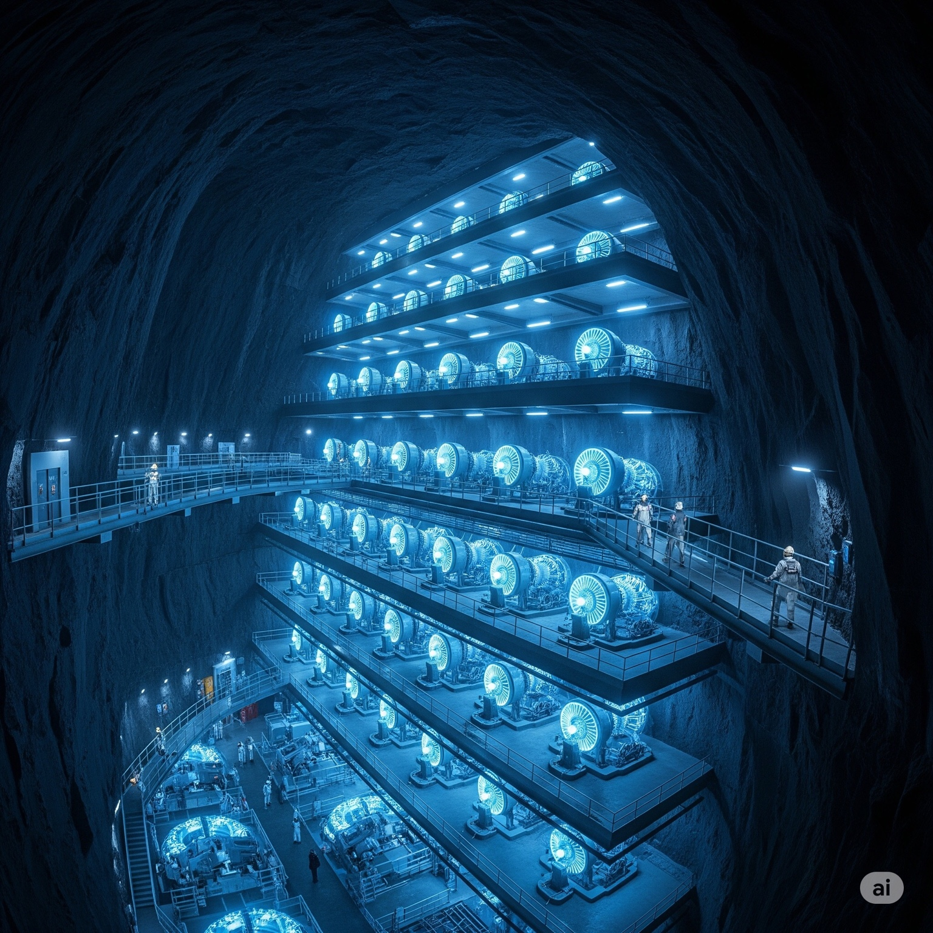

## Scene 3: The System Cross-Section

A cutaway schematic reveals the Sentinel’s elegant core: Intake → Vertical Shaft → Turbine Cavern → Lower Reservoir → Recharge Cycle.

[Ensure image includes 3mm bleed and is positioned with crop marks.]

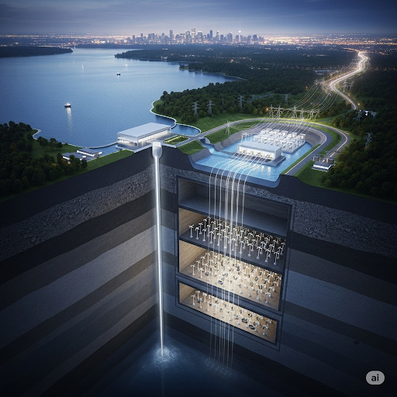

## Scene 4: The Grand Finale

Southern Ontario at night, Toronto’s skyline glowing. This visual represents grid stability, clean power, and future-proofed infrastructure.

[Ensure image includes 3mm bleed and is positioned with crop marks.]

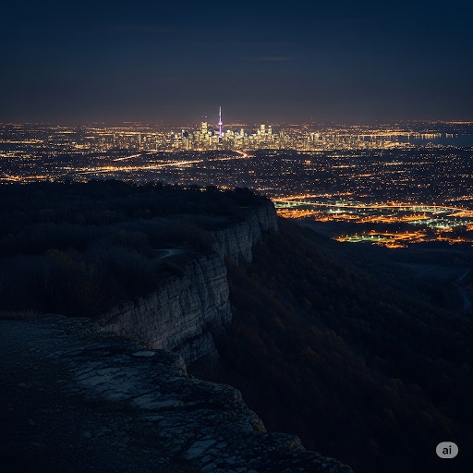

# The Technical Foundation

|  |  |
| --- | --- |
| Parameter | Value |
| Vertical Head (h) | 1200 meters |
| Flow Rate (Q) | 100 m³/s (assumed colossal scale) |
| Efficiency (η) | 90% |
| Gravity (g) | 9.81 m/s² |
| Water Density (ρ) | 1000 kg/m³ |

Formula: P = η × Q × h × g × ρ

Result: P ≈ 1,060 Megawatts (MW)

Energy Output (Daily Cycle):

|  |  |
| --- | --- |
| Operational Time | Energy Generated |
| 8 hours/day | 8,480 Megawatt-hours (MWh/day) |

# Ecological & Community Impact

* Minimal Surface Disruption: Intake structures designed to blend into the landscape.
* Subterranean System: Reduces environmental impact versus traditional dams.
* Peak Demand Support: Balances renewables and stabilizes grids during critical times.
* Resilience for Southern Ontario: Protects cities like Toronto from blackouts.

# Legal Citation & Ownership

Document Title: Sentinel East™ – Advanced Hydro Power Storage System: Visual & Technical Brief  
Author: Clive Appleby, Eclipse Inc. Founder & CEO  
Date: July 2025  
Official URL: www.cliveappleby.com/news/sentinel-east  
  
Citation (APA Style):  
Appleby, C. (2025, July). Sentinel East: Advanced Hydro Power Storage System – Visual & Technical Brief. Eclipse Inc. Retrieved from www.cliveappleby.com/news/sentinel-east  
  
Legal Notation:  
© 2025 Eclipse Inc. All rights reserved. Distributed under advisory and strategic partnership guidelines in collaboration with Accenture and Appleby Global Partners. This document is part of the Eclipse Infrastructure & Energy Innovation Archive.